I have setup the Mysql server in private subnet and Mattermost in public subnet.. After installing and updating the config files, I was able to connect to the mattermost and started listening from 8065 port as shown below…

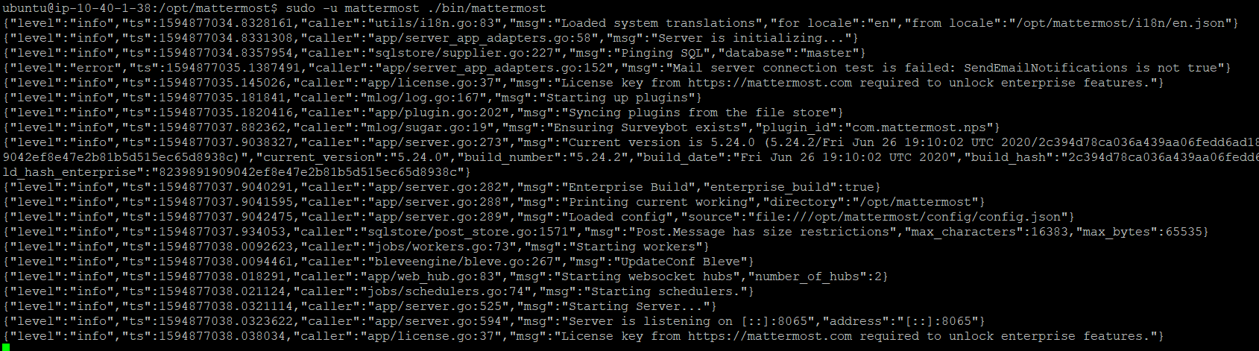

After starting the mattermost service..

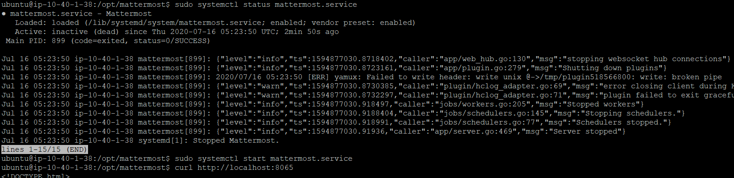

After running the CURL command, I got the below message..

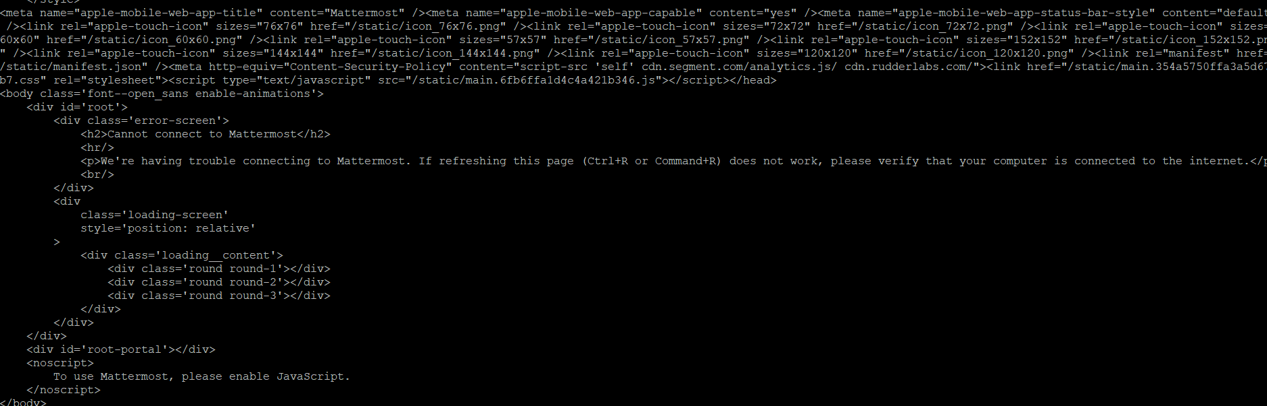

Now I am unable to open in the browser.. I have raised this issue in forum.mattermost as well… Need help in solving this error…

